LeetCode Assignment
Question Name: total distance traveled
LeetCode question number: 2739
Platform: LeetCode
Problem link: https://leetcode.com/problems/total-distance-traveled/submissions/2192473815/
C source code
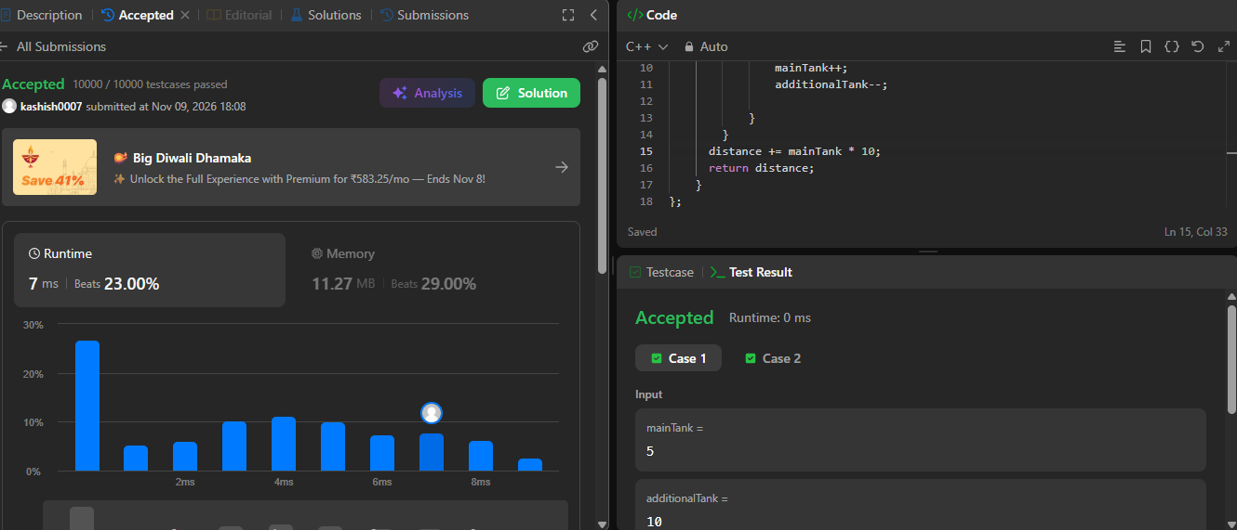

Name – Kashish Upadhyay
Roll no- 26csu254

